Group Project 2 - Group 10

**Q1. Risk Management for Dynamic Portfolios**

**Q1.2 Portfolio Constructions**

**Q1.2.1**

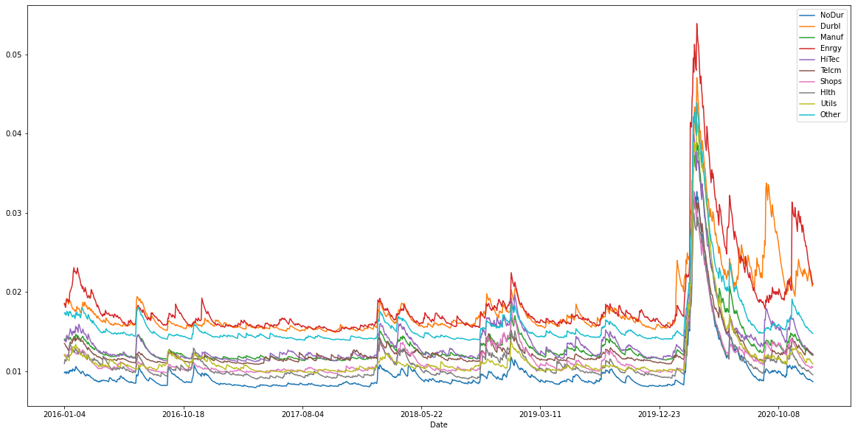

Figure 1 Estimated dynamic volatilities

From Figure 1, we can see that the volatilities of 10 industries reached the highest level around March 2019. This could be due to COVID-19 outbreak around that period. We can also see that the energy industry has the highest volatility among all 10 industries in general.

**Q1.2.2**

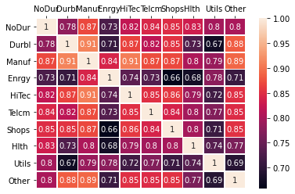

Figure 2 Correlation matrix on 4-Jan-2016

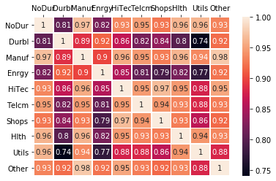

Figure 3 Correlation matrix on 25-Mar-2020

The correlation matrix on 25-Mar-2020 has a lighter color when compared with 4-Jan-2016. This means that correlation among 10 industries could be higher than usual when extreme cases like covid-19 happen to the market.

**Q1.2.3**

From the above chart, we can observe that dynamic weightage on 4 January 2016 is quite similar to the static weightage. While the dynamic weightage on 25 March 2020 is different from the other two. Weight in some industries even changes from positive to negative due to covid-19 or other impacts.

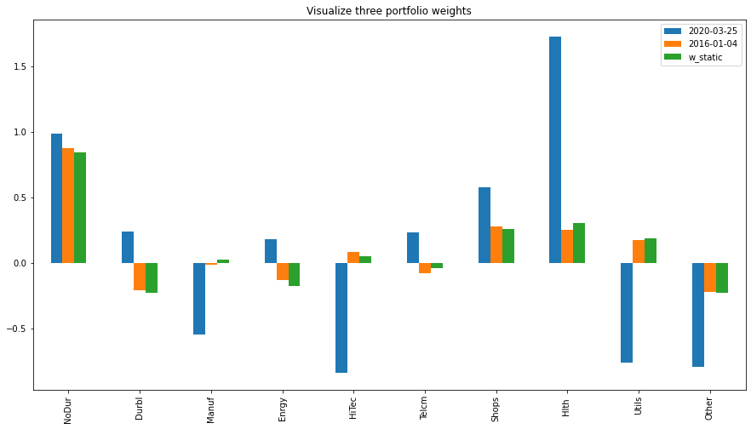

Figure 4 Portfolio weights

**Q1.2.4**

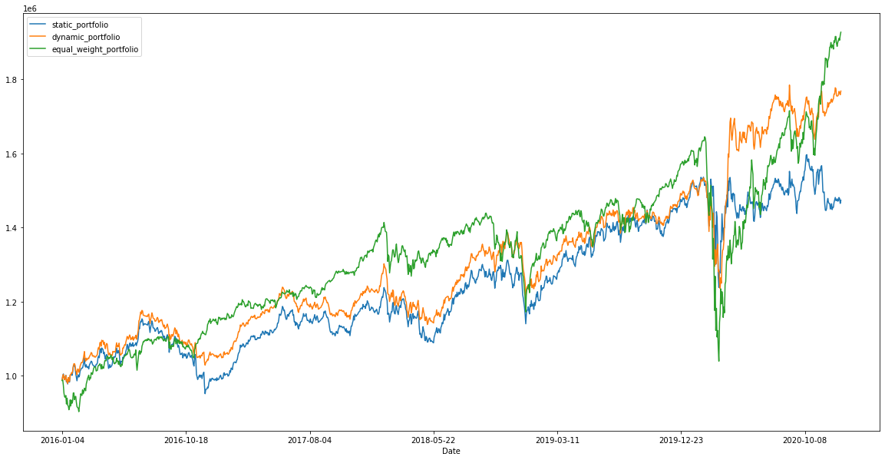

Figure 5 Dynamics of the total portfolio value

The total portfolio value for different strategies is displayed as below. An equally weighted portfolio is having a better return under normal time. However, during extreme economic downturn such as Covid-19 period at the beginning of 2020, equal weighted portfolio returns dropped more significantly than dynamic portfolios or static portfolios derived by GMV. Also, the dynamic portfolio is more stable compared to static portfolios.

**Q1.3 Risk Evaluation**

Below table shows the one-day 99% VaR, ES, stressed VaR, stressed ES for the 3 portfolios. Detailed code can be found in jupyter notebook.

Table 1 Risk evaluation (unit: dollar)

|  |  |  |  |
| --- | --- | --- | --- |
|  | Equally Weighted | Static GMV | Dynamic GMV |
| VaR | 50146.61 | 37473.82 | 37325.29 |
| ES | 78349.83 | 60956.38 | 50168.34 |
| Stressed VaR | 123287.88 | 100632.13 | 58281.95 |
| Stressed ES | 132618.59 | 110281.89 | 78131.74 |

As there are several 250-day periods that have the equal stressed VaR and stressed ES, here we only mention the period that appears earliest. For equally weighted Portfolio, the period for stressed VaR and stressed ES is from 2019-03-20 to 2020-03-16; for static GMV Portfolio, the period for stressed VaR and stressed ES is from 2019-03-26 to 2020-03-20; For dynamic one, the period for stressed VaR and stressed ES is from 2019-06-17 to 2020-06-11.

**Q1.4 Further Thought**

Two approaches are taken to find a better portfolio which can perform better when extreme losses happen.

First Approach - EWMA

Dynamically estimate the covariance matrix using EWMA method with

* lambda equals 0.95.
* V 1(i, j) = Vˆ (i, j). That is, the initial value is the sample covariance matrix obtained from the pre-2006 data;
* Fort≥2,Vt(i,j)=lambda* VL(i,j)+(1-lambda) × r_validate(t−1,i)×r_validate(t−1,j).

The final VaR and ES is computed as below:

Table 2 Risk evaluation under EWMA (unit: dollar)

|  |  |
| --- | --- |
|  | Dynamic GMV using EWMA |
| VaR | 41406.50 |
| ES | 59808.53 |
| Stressed VaR | 75869.39 |
| Stressed ES | 82179.32 |

We can see that it performs better than Static GMV and Equally Weighted portfolios. If we use optimizer to find a better lambda, it is possible that EWMA outperforms Dynamic GMV portfolios as well.

Second Approach - GARCH with heavier weight assigned to recent observations

We noticed that the recent market behavior in 2020 is inconsistent with most of the historical data prior to 2016, and most recent data are more valuable when extreme cases happen. Therefore we assign more weight to recent observed returns than to the previous estimations. We use gamma = 0.05, alpha = 0.05, beta = 0.9 for the calculation, and the final VaR and ES is computed as below:

Table 3 Risk evaluation under GARCH (unit: dollar)

|  |  |
| --- | --- |
|  | GARCH GMV with heavier weight assigned to recent observations |
| VaR | 35295.98 |
| ES | 49918.6 |
| Stressed VaR | 59424.14 |
| Stressed ES | 76664.4 |

The one-day 99% VaR and ES of this portfolio are less than any portfolio mentioned in the previous section. Thus it has a better protection against extreme losses. In order to improve this strategy, we could possibly use an optimizer to find the best parameters to address the recent market situation.

**Q2.1**

According to Vasicek’s Result, conditional on F, the probability of one turbine having failure follows the formula below:

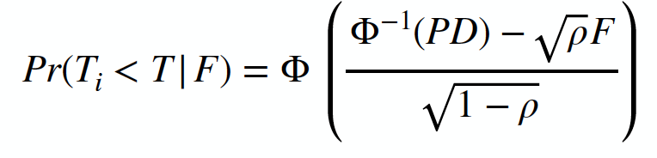

The PD in the above formula is the Probability of Default at time T, defined below:

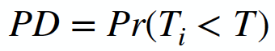

This value has been given in the question for one turbine, which is 0.01.

We adopt the simulation methodology below:

1. Draw 10,000 samples of F from the standard normal distribution implied by the single-factor Gaussian copula model.
2. For every sample of F, calculate the conditional probability of power outage (conditional on that sample of F) using the first formula listed above.
3. For every sample of F, calculate the unconditional probability of power outage using binomial distribution, where we calculate the cumulative probability when the number of failed turbines >= 3.
4. Take the average value among the 10k samples.

Table 4 Probability of power outage

|  |  |
| --- | --- |
| Probability of power outage | ⍴ value |
| 0.08308898511056029 | 0 |
| 0.12120824752164626 | 0.1 |
| 0.12696702890850564 | 0.2 |
| 0.12177476280931948 | 0.3 |
| 0.11199066307504149 | 0.4 |
| 0.09988755516455056 | 0.5 |
| 0.08634118433132605 | 0.6 |
| 0.07165876854292016 | 0.7 |
| 0.05580119047799634 | 0.8 |

The probability of power outage, or Pr(number of working turbines < 100) values when ⍴ ranges from 0 to 0.8 are shown in Table 4.

**Q2.2**

Using the same methodology above, we calculate the maximum probability of power outage among when ⍴ values range from 0 to 0.8, by iterating the value of N from 101 to 1000. We can observe that, the maximum probability of power outage among when ⍴ values range from 0 to 0.8 drops as N becomes larger in value. For the chart below, y axis is the maximum probability of power outage among when ⍴ values range from 0 to 0.8, the x axis is the value of N.

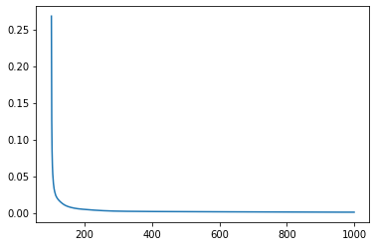

Figure 6 Maximum probability of power outage

From the result list of the maximum probability of power outage among when ⍴ values range from 0 to 0.8, we can find the smallest N value when the probability value drops just below 0.1%. The value we obtain is when N = 810, and the corresponding max probability is 0.099869%.